GoTracker

Team members: Oskar Zetterström, Kristofer Svensson, Amar Sadikovic

Goal of the app

Make an app tracking your running, bicycle or walking sessions. Including your time, date, speed, route and distance. Also saving your history so you can watch your progress.

Main Features - Must Have

* GPS location – show location on map with a icon that also shows direction faced.
* Stepcounter – counting your steps
* Save your runs and store them to watch progress ( watch in listview calendar, store in database)
* Timer for your runs
* Start and stop your run.
* Save your run.
* Delete your old runs.

Could have

* Preset distance – alert when finish
* Having your own profile
* Share with friends
* 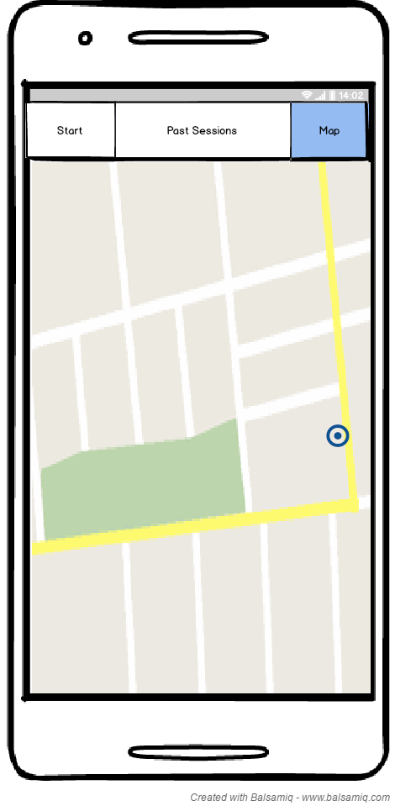Show weather with API showing weather at your location

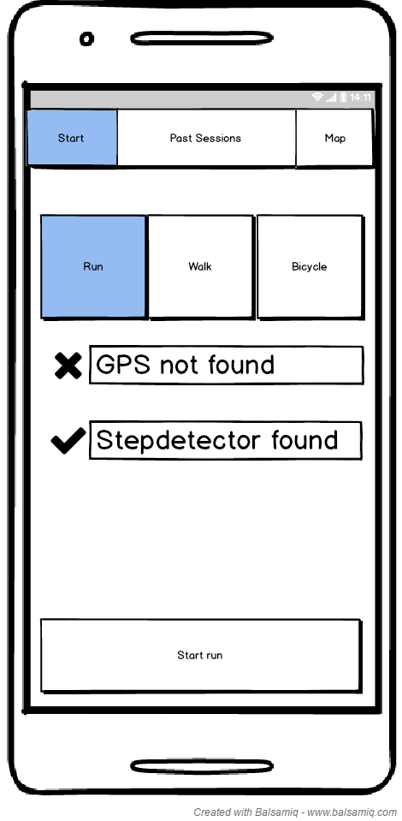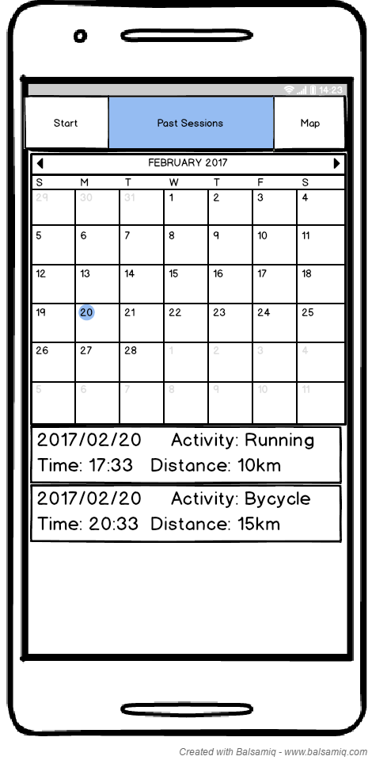

Resources

* Google maps API
* GPS Sensor
* Step counter sensor
* Database

Tasks

Task 1

* Google maps – show your route with a line
* Direction headed
* Distance

Task 2

* Getting correct stepcounts
* Time for your run
* Calendar with your runs(Calendar connected with listview)

Task 3

* Saving all info into Database

Roles

* Task 1 = Oskar Zetterström
* Task 2 = Kristofer Svensson
* Task 3 = Amar Sadikovic

Overall most work will be done togheter in school

Sprint

Sprint 1 (22/2 – 1/3)

* Get google maps working with gps
* Database with all columns ready

Sprint 2 (2/3 – 8/3)

* Show your route on google maps.
* StepCounter and time recording

Sprint 3(9/3 – 13/3)

* Calender
* GoogleMaps ready
* Stepcounter and time recording
* Save to database

Spring 4(14/3 – 16/3)

* Fix minor bugs
* Complete design